Agent User Guide (UAT)
Contents
Document Version Control 2
Inbound Calls 3
Tagging the Call to Payment App 3
Proceed to Payment 3
Proceed to Payment - Capturing Customer Payment Card Details 4
Secure Card Data Capture 4
Payment Gateway Response 5
Callstream “Test Gateway” Test Cards 6

Document Version Control
Version | Comments | State | Last updated  (Date & signature)
1.0 | First version document created | RELEASED | 16/05/2018 IM
1.1 | Avs Incorporated |  | 16/11/2020 JT

Intended Audience:
This documentation has been designed for use in a Standalone Virtual Terminal environment
Merchants that subscribe to a CRM/Integrated Virtual Terminal will receive further documentation for LIVE process once the integration has been fully developed, tested and released to live.

Inbound Calls
Inbound calls will be delivered via Direct Call or IVR to Agents as normal.
Not every inbound call will lead to payment, so Agents only need to open their PCI Console, if a card payment is part of the call.
Next, the Agent should log into their Vault (PCI) console

Tagging the Call to Payment App
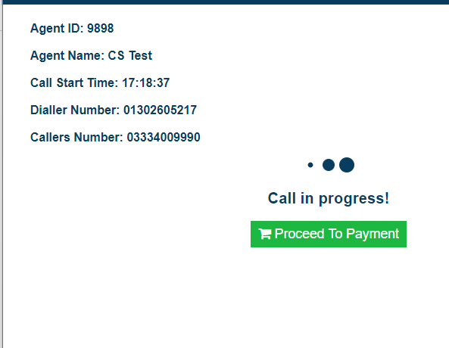
If the inbound call leads to card payment capture, the Agent first needs to TAG the inbound call to their payment application.
This is done by keying their # AGENT ID # on their telephone keypad (handset)
On making the TAG, if successful then the Agent will hear TWO PING TONES in their ear – this signals that the inbound call has been tagged to the agent successfully
On the Agents Vault PCI console, the call details will now show

Proceed to Payment
Click PROCEED TO PAYMENT

Proceed to Payment - Capturing Customer Payment Card Details
The Customer Card Payment screen will open
- Details will auto filled and the agent will only need to collect card details
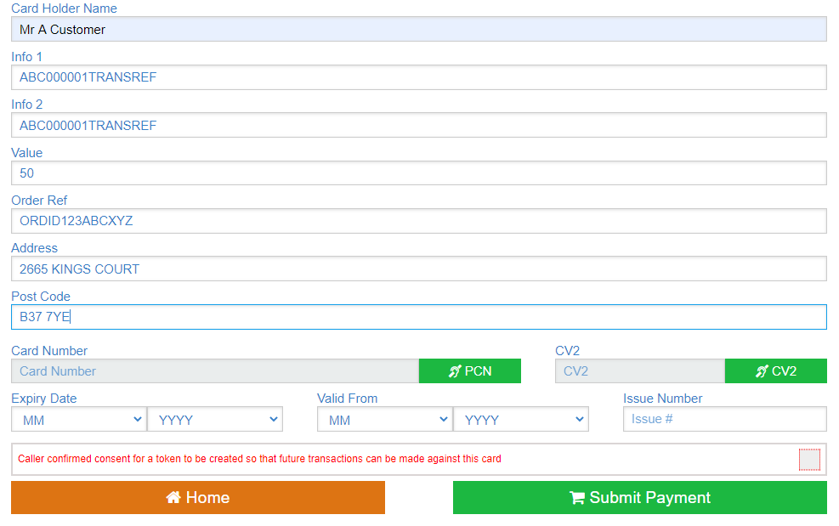
NAME – The Cardholder name as shown on the Payment Card
INFO 1 – Information field
INFO 2 – Information field
ORDER VALUE – Input the payment amount being made on the Card (this should include all Fees, and is the Total Amount being taken as payment)
ORDER ID – Reference the unique order/ref id, as may be shown on the CRM
ADDRESS – Input first line of address. (Card holders address)
POSCODE – Post code (Card Holders postcode)

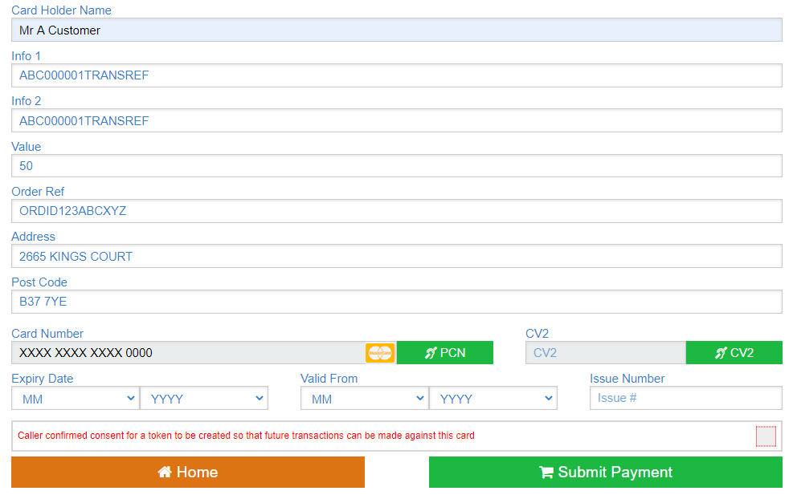
Secure Card Data Capture
After the above details have been input, the Call then enters the most secure mode.
The Caller will no longer relay their Payment Card details verbally – instead the information will be transmitted securely just using the buttons on the callers telephone keypad
Agents are connected fully to the caller, and should advise of the process and coach the Caller through.
- When the Agent is Ready, they should Click GET “PCN”
The Card Number bar will turn ‘Yellow’ highlight
- The Caller should now input the long number on the front of their Payment Card using the buttons on their telephone keypad only – DO NOT READ OUT!
The DTMF digits will Register on each input, and show in this Bar to the Agent, asterisked out apart from the last 4 digits.
- The Caller should press # when they have completed input to submit.
The CARD TYPE will validate – and shows the card type (Mastercard, Visacard, Debit card, etc)
If the card shows as INVALID, or the wrong number has been input, the Agent is in control and can restart the process simply by pressing the GET PCN button once more.
After card type validation, the Agent also collects the Card Security (CV2) code securely using the same method.
- Agent presses the GET “CV2” button, which makes the dialogue box ‘highlighted’
- The 3 digit CV2 code – found in the Signature strip on the back of the Payment Card is then input by the Caller – pressing # also to commit
The Valid From and Expiry Dates are gathered verbally by the Agent and completed using the Drop down boxes
When all the details are confirmed as CORRECT, the Agent then presses ‘PROCESS’ to submit the transaction request to the Payment Gateway for Authorisation

Payment Gateway Response
The next screen will show the transaction being submitted, and then either Authorising or Failing
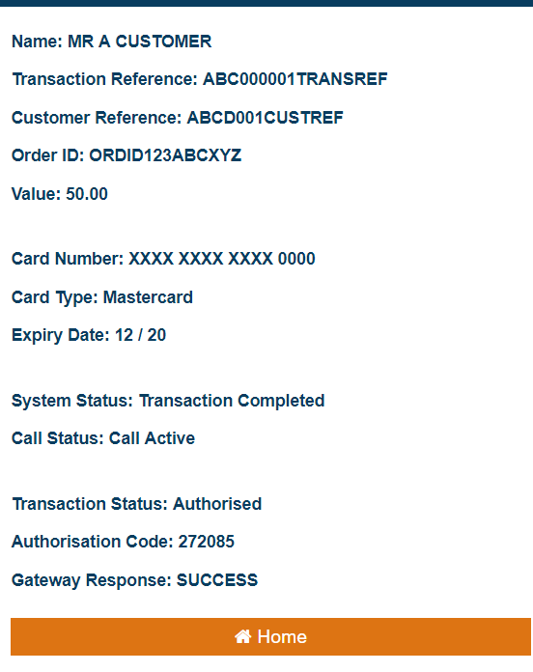
If the transaction Authorises, then a receipt reference number will be generated in “Authorisation Code” field

Callstream “Test Gateway” Test Cards
When running at the CALLSTREAM TEST GATEWAY, please use the values below for the credit card number and the transaction values – to simulate specific gateway responses
Test Credit Card Numbers (Callstream test payment card numbers)
Mastercard |  | 5100 0800 0000 0000
Visa Delta - UK |  | 4406 0804 0000 0000
Visa Delta - Non UK |  | 4462 0300 0000 0000
Visa |  | 4917 6100 0000 0000
American Express |  | 3700 0020 0000 000
Maestro (UK only): |  | 6759 6498 2643 8453
Diners |  | 3670 0102 0000 00
Gateway Responses (Value simulates Gateway response type)
£XX.00 to £XX.09 |  | Authorised
£XX.10 to £XX.19 |  | Declined
£XX.20 to £XX.29 |  | Failed Validation
£XX.30 to £XX.39 |  | General Error
£XX.40 to £XX.99 |  | Authorised
Gateway Delay (Value simulates time taken for Gateway to respond)
£10.YY |  | 1 Second
£50.YY |  | 5 Seconds
£100.YY |  | 10 Seconds
£600.YY |  | 60 Seconds
£1200.YY |  | 120 Seconds

For CV2 code – use any 3 digit code (or 4 digits for AMEX)
For Start Date – use any given date in the past
For Expiry Date – use any given date in the future

